**PYASSIST – MULTI-CRITERIA DECISION-MAKING**

BY

**Omar Faraz Yusuf (Enrolment No. 20/11/EC/014)**

under the guidance of

**Dr. Ankit Kumar Jaiswal, School of Engineering**

**JNU, Delhi**

in the partial fulfilment of the requirements

for the award of the degree of

**Bachelor of Technology**



School of Engineering

Jawaharlal Nehru University, Delhi

**May, 2024**

**JAWAHARLAL NEHRU UNIVERSITY**

**SCHOOL OF ENGINEERING**

# DECLARATION

I declare that the project work entitled **“PYASSIST – Implementing Multi-criteria Decision-Making”** which is submitted by me in partial fulfillment of the requirement for the award of degree B.Tech. to School of Engineering, Jawaharlal Nehru University, Delhi comprises only my original work and due acknowledgement has been made in the text to all other material used.

**JAWAHARLAL NEHRU UNIVERSITY**

**SCHOOL OF ENGINEERING**

# CERTIFICATE

This is to certify that the project work entitled **“PYASSIST – Implementing Multi-criteria Decision-Making”** being submitted by **Mr. Omar Faraz Yusuf**(Enrolment No.- 20/11/EC/014) in fulfilment of the requirements for the award of the **Bachelor of Technology** in **Computer Science Engineering**, will be carried out by him under my supervision.

In my opinion, this work fulfils all the requirements of an Engineering Degree in respective stream as per the regulations of the School of Engineering, Jawaharlal Nehru University, Delhi. This thesis does not contain any work, which has been previously submitted for the award of any other degree.

**Dr. Ankit Kumar Jaiswal**

(Supervisor)

Assistant Professor

School of Engineering

Jawaharlal Nehru University, Delhi

**JAWAHARLAL NEHRU UNIVERSITY**

**SCHOOL OF ENGINEERING**

# ACKNOWLEDGMENT

We extend our heartfelt appreciation to Dr. Ankit Kumar Jaiswal, whose unwavering guidance and support have been instrumental in shaping the trajectory of this project endeavour. Dr. Jaiswal's profound expertise, keen insights, and dedication to the field have left an indelible mark on the success and outcomes of this project. His mentorship provided not only scholarly direction but also a nurturing environment for intellectual growth. I am deeply grateful for his commitment to excellence, encouragement during challenging phases, and the wealth of knowledge he generously shared. This project stands as a testament to the impact of his mentorship, and we are privileged to have had the opportunity to work under his guidance.

List of Contents

**Content Page No.**

Declaration………………………………………………………...…………................................2

Certificate………………………………………………...……………........................................3

Acknowledgement …………………………………………………………..........................…….4

Table of contents…………………………...……………………………….................................5

List of Figures…………..…………………………………………..……………………….................6

Abstract……………………………………………………………………......………………..………….7

**Chapter 1: INTRODUCTION**

1.1 Introduction……………………………………………………………….………………………..….8

1.2 Project Objective…………………………………………………………...….........................9

1.3 Organizations of Chapters…………………………………….…………..………………...……9

**Chapter 2: LITERATURE REVIEW**

2.1 Review of Existing research...............................................................................10

2.2 Shortcomings and Purpose of the study……………….……………………....................10

**Chapter 3: PROPOSED WORK AND METHODOLOGY**

3.1 Data fetching and Pre-processing………………………………………………………………..11

3.2 Simple Additive Weighting…………………………….……………………….......................11

3.3 Analytical Hierarchy Process………………………………………………………………………12

3.4 TOPSIS…………………………………………………………………………………………………...12

3.5 PROMETHEE……………………………………………………………………………………………13

3.6 Removing Outliers……………………………………………………………………………………13

3.7 Sensitivity Analysis Graph………………………………………………………………………….13

**Chapter 4: RESULT DISCUSSION**

Result discussion….……………………………………………..……………………………….......14-16

**Chapter 5: CONCLUSION AND FUTURE SCOPE**

5.1 Conclusion……………….…………………………………………………………………...……….17

5.2 Future Scope………………………………………………………….....................................17

**REFERENCES**……………………………………………………………………………………………….18

List of Figures:

**Detail of Figures Page No.**

* 1. Basics of MCDM………………………………………….…………….……………….…8
  2. Places of Interest Data……………………………………………………………….….11
  3. Hierarchical Structure AHP………………………………………………………….…12
  4. Promethee Process Diagram….………………………………………………………13
  5. Heatmap for Sensitivity Analysis.…………………………………………………….14
  6. Line Plot for Sensitivity Analysis………………………………………………………………..15
  7. Folium map Representation……………………………………………………………………..16

Abstract

This project aims to develop a comprehensive solution for trip planning using advanced algorithms and web technologies. The system leverages multi-criteria decision-making (MCDM) techniques to help users select the best places to visit from a list of options.

The user begins by providing their current location and a list of places they wish to visit. The system then retrieves detailed information about these places from a Places API, including ratings, reviews, distance from the current location, and popularity

Using this information, the system applies Multi-criteria decision-making (MCDM) algorithms to evaluate the options based on multiple criteria, such as ratings, distance, and popularity, to determine the optimal sequence of places to visit. The chosen places are then connected on a map, and a route is planned to minimize travel time and distance.

The map visualization is powered by Folium, a Python library that integrates with Leaflet.js for interactive mapping.

Overall, this project demonstrates the practical application of Multi-criteria decision-making (MCDM) in trip planning, providing users with a user-friendly and efficient tool for organizing their travel itineraries.

Chapter -1

Introduction

**1.1 INTRODUCTION**

***Multi-criteria decision making (MCDM)****,* also known as multi-criteria decision analysis (MCDA) or multiple criteria decision making (MCDM), is a field of study and a set of methods used to evaluate and rank alternatives or options when faced with complex, often conflicting, criteria or objectives. It is widely used in various disciplines, including economics, engineering, management, and environmental sciences, to support decision-making processes involving multiple and often conflicting criteria.

One of the earliest instances of research on multi-criteria decision-making can be attributed to Benjamin Franklin, who introduced the concept of moral algebra. Since the 1950s, numerous empirical and theoretical researchers have focused on developing and refining MCDM methods. Their goal has been to create a framework that effectively structures decision-making problems and derives preferences from alternative options through mathematical modelling.

The key concepts in MCDM include criteria, alternatives, weights and rankings. Criteria are the factors that help to make decisions and rank the alternatives. It includes both quantitative and qualitative. Alternatives are the different options available for decision-making. Weights are entities attached to the importance of a particular criteria. Ranking is the core concept in which we rank the options/prospects.

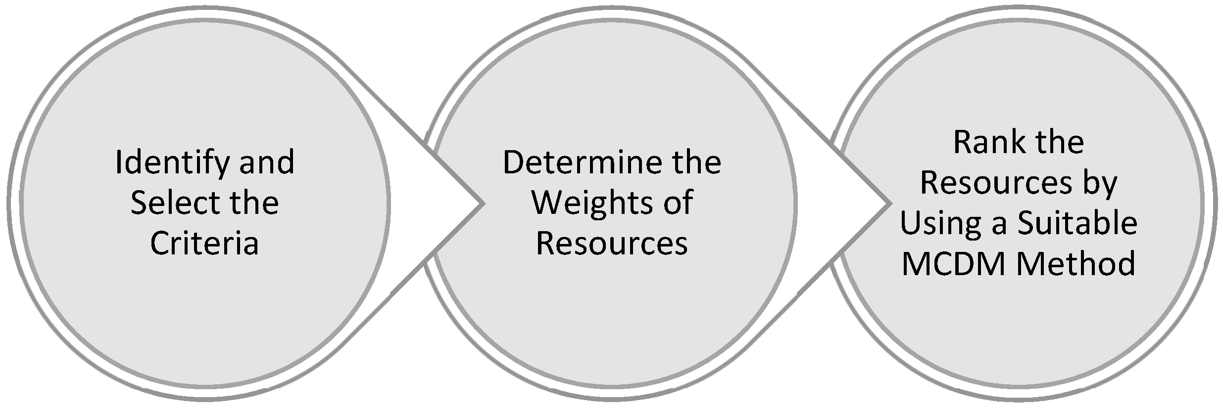

Fig 1.1 Basics of MCDM

Each algorithm in Multi-criteria decision-making (MCDM) traditionally begins with plotting a decision matrix with alternatives and criteria as the rows and columns respectively. Each cell in it represents the performance of an alternative on a criterion. Normalization is the next step in this discipline which involves scaling down the criteria values to a common scale to avoid discrepancies due to different measurement units.

**1.2. PROJECT OBJECTIVE**

The primary objective of this project is to

1. Implement and compare various models of multi-criteria decision-making
2. Determine the most optimal prospect for a user
3. Provide with a connection of chosen places using routing.

**1.3. ORGANIZATIONS OF CHAPTERS**

The project consists of five chapters and the overview of all the chapter are as follows:

**Chapter 1:** Provides a brief introduction of the background, the objectives of the project involved in accomplishing the project.

**Chapter 2:** Gives an overview of available literature.

**Chapter 3**: Describes the details of proposed work and methodology used in this project work.

**Chapter 4:** Gives the discussion about the measured results.

**Chapter 5**: Presents the conclusion of this project work and future scope of the work.

References: In the last section of this project, used references are mentioned.

Chapter-2

Literature Survey

Multi-criteria decision-making is a vital discovery to address decision-making situations involving various conflicting factors (or criteria). Its significance lies in its ability to provide structured and rational decision support without the effect of the type of fields concerned. The enormous use case of this tool encourages me to carry out an in-depth analysis and study of MCDM and compare the advantages of its individual components.

**2.1 REVIEW OF EXISTING RESEARCH**

The field of multi-criteria decision-making is quite old. There has been innumerable research on this subject along with various book published on the ABC’s of MCDM. One of the earliest studies on decision-making processes were by Benjamin Franklin. Since the 1950s, empirical and theoretical scientists have explored MCDM methods to enhance mathematical modelling capabilities, providing frameworks to structure decision problems and generate preferences from alternatives. In the decade 1960s and 1970s, many foundational MCDM methods were devised including Simple Additive Weighting (SAW), Analytical Hierarchy Process (AHP) and TOPSIS.

**2.2** Shortcomings and Purpose of the study

Current studies of multi-criteria decision-making are focused on integrating it with modern technologies like Machine Learning and Artificial Intelligence. Although, a possible integration of these technologies can be a major break in the field of computer science, the practical applications of these technologies are hardly implemented and shown in studies. The basis of decision-making based on multi-criteria decision-making algorithms is to select the most optimal algorithm for a particular use case which might not be the same in another case.

The purpose of this study is to implement one such use case of multi-criteria decision-making and compare the best tool for making decisions. This can be objectively reduce the number of hours in choosing prospects and help us make better choices.

Chapter-3

Proposed Methodology

I aim to implement different Multi-criteria decision-making (MCDM) algorithms and predict the best and optimal alternative among a number of choices based on a number of criteria as provided by the Places API.

3.1 DATA FETCHING AND PREPROCESSING

The dataset used will be generated from utilising Geoapify API Places API and Places Detail API for retrieving information about the places of interest in form of a csv. This Places API generates 10 relevant places within a given radius. It also generates an fsq Id which can be utilised to get information from Places Detail API.

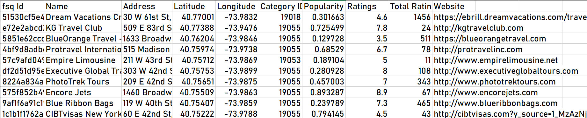

Fig 3.1 Places of Interest Data

The different MCDM algorithms to be implemented are discussed here.

* Simple Additive Weighting (SAW)
* Analytic Hierarchy Process (AHP)
* TOPSIS (Technique for Order of Preference by Similarity to Ideal Solution)
* Promethee (Preference Ranking Organization Method for Enrichment of Evaluations)

3.2 Simple Additive Weighting (SAW)

This method was first proposed by Fish burn in 1967 and is considered as one of the simplest MCDM methods. Each alternative is assessed with regard to every attribute. This is a single step algorithm and uses the following formula:  
 **Si =**

Where Ai represents the performance score of a particular alternative.

3.3 Analytic Hierarchy Process (AHP):

Developing a hierarchical structure with a goal at the top level, the attributes/criteria at the second level and the alternatives at the third level.

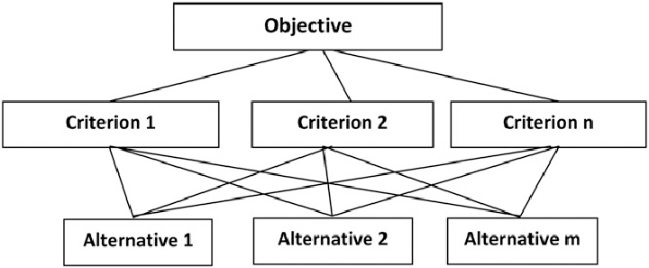

Fig 3.3 Hierarchical Structure

Determine the weights of the attributes with respect to the goal. Pairwise comparison matrix is created with the help of scale of relative importance.

3.4 TOPSIS (Technique for Order of Preference by Similarity to Ideal Solution)

TOPSIS (Technique for Order of Preference by Similarity to Ideal Solution) is a multi-criteria decision-making (MCDM) method used to determine the best alternative among a set of alternatives based on their similarity to the ideal solution. We normalize the decision matrix. We then calculate the ideal best and ideal worst for each criterion and add it to the decision matrix indicate by Vj+ and Vj-.

Then we calculate the Euclidean distance from ideal best:  
 

where,

Di+ is the Euclidean distance from the ideal best solution for alternative 𝑖

Similarly, we calculate the Euclidean distance from ideal worst. Finally, a relative closeness coefficient is calculated to rank the alternatives.

3.5 Promethee (Preference Ranking Organization Method for Enrichment of Evaluations)

The Preference Ranking Organization Method for Enrichment of Evaluations is a sophisticated multi-criteria decision-making technique. It was developed by Jean-Pierre Brans and Bertrand Mareschal in the 1980s. The method utilizes preference and indifference thresholds to handle the varying sensitivity of criteria. It calculates positive and negative outranking flows for each alternative, representing the degree to which an alternative is preferred over others and vice versa. These flows are then used to determine a net outranking flow, which ranks the alternatives.

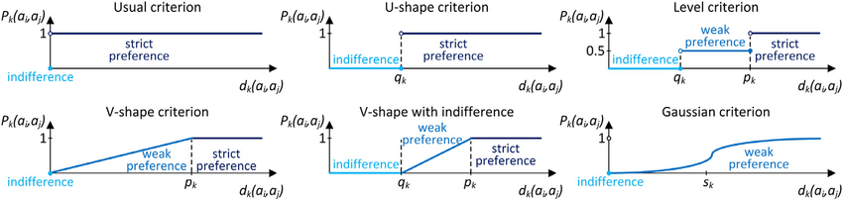

Fig 3.5 Promethee Process Diagram

3.6 REMOVING OUTLIERS

The next step after assembling the dataset is to remove the outliers and to furnish the data for processing for Multi-criteria Decision-Making algorithms. Fields such as id, Name, Address and Website which hold no importance or relevance in the result and process of evaluating the ranking of the alternatives are removed.

3.7 PLOTTING SENSITIVITY GRAPH

Finally, we plot a sensitivity graph for each criterion. The graph shows the sensitivity of alternatives rankings upon changing the weights of the criteria. This helps to choose the optimal algorithm for selecting the alternative.

Chapter-4

Result Discussion

The eventual output is a comparison of different algorithms we used in multi-criteria Decision-Making. This can help in selection of an alternative either optimally or according to the user’s needs. The weight changes reflect the alternatives’ score according to a given algorithm given the same data.

One of the only metrics to compare in case of multi-criteria Decision-Making is sensitivity analysis. Sensitivity analysis is a technique used to study how the variation (uncertainty) in the output of a model can be apportioned, qualitatively or quantitatively, to different sources of variation in the input of a model. In MCDM, different criteria are often assigned weights based on their relative importance. Sensitivity analysis involves varying these weights to see how changes affect the overall rankings or decisions. This helps in understanding the robustness of the decision-making process to changes in weights.

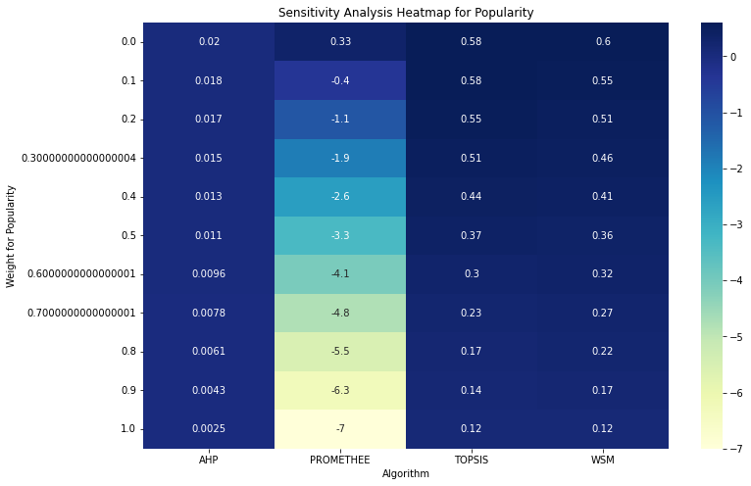

Fig 4.1 Heatmap for Sensitivity Analysis

Heatmaps are graphical representations of data where values in a matrix are represented as colors. They are commonly used to visualize complex data sets and patterns. In this case they are utilized to visualize the sensitivity caused by modifying the weights given to a particular criterion.

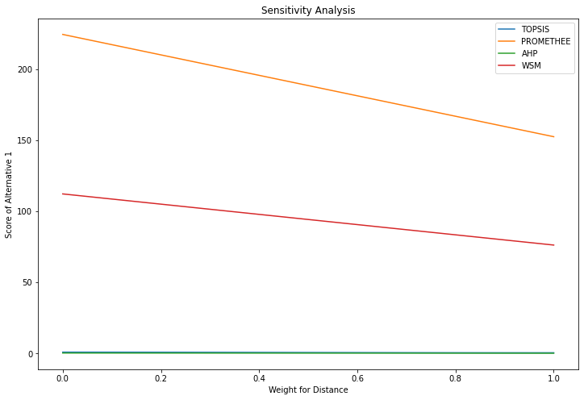

Fig 4.2 Line Plot for Sensitivity Analysis

The above line plots using matplotlib to give a different perspective visualization, i.e. a continuous one.

Eventually, we select the best alternative from a set of data provided by Places API after implementing and analysing the best algorithm. I have utilized Folium maps for plotting and mapping the chosen places and connecting them to each other. This helps in visualization and is the final output.

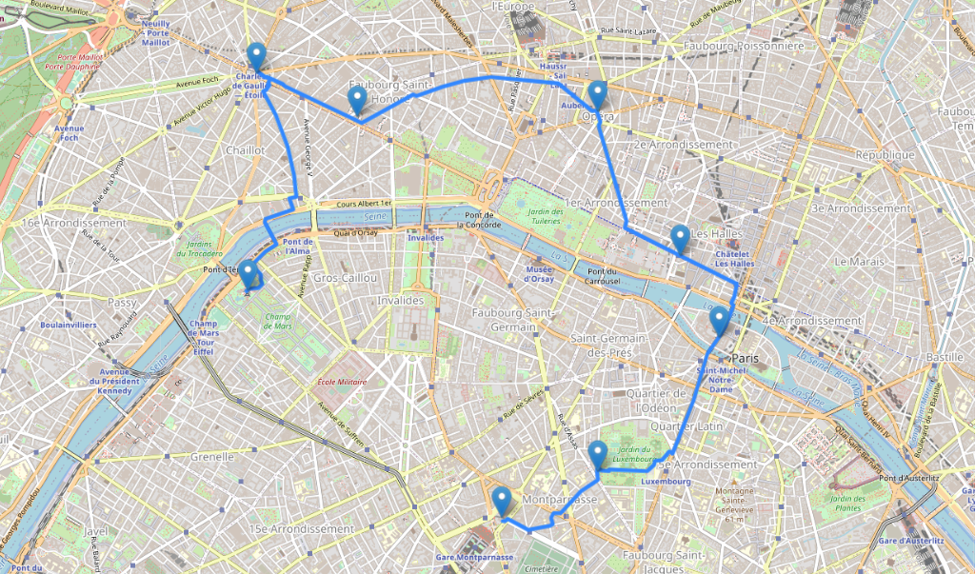

Fig 4.3 Folium map Representation

Chapter-5

Conclusion and Future Scope

**5.1 CONCLUSION**

In conclusion, this project successfully demonstrates the integration of Multi-Criteria Decision Making (MCDM) algorithms to optimize the selection of places of interest (POI) based on user-defined criteria. By leveraging Python and Places API, we effectively gather, evaluate, and visualize the best options, ultimately saving users time and money.

**5.2. FUTURE SCOPE**

In the future, integrating Multi-Criteria Decision Making (MCDM) with Python can revolutionize app development, providing personalized decision support to users based on their specific filters and preferences. By leveraging Python's robust libraries and frameworks, developers can create applications that dynamically evaluate various criteria to offer the best options for users. Furthermore, incorporating real-time data from APIs can enhance the accuracy and relevance of the suggestions. Python's versatility allows for seamless integration with various data sources, enabling apps to adapt to changing user requirements and environmental factors. This approach can be applied across various domains, such as travel planning, restaurant selection, and shopping, ultimately saving users time and effort while making informed decisions.

References

# [1] Multi-Criteria Decision Making (MCDM) Methods and Concepts by  Hamed Taherdoost and Mitra Madanchian Department of Arts, Communications and Social Sciences, University Canada West, Vancouver, BC V6B 1V9, Canada Hamta Group, Research and Development Department, Hamta Business Corporation, Vancouver, BC V6E 1C9, Canada

**[2]** [**https://www.researchgate.net/figure/Preference-functions-of-the-PROMETHEE-method_fig1_350862489**](https://www.researchgate.net/figure/Preference-functions-of-the-PROMETHEE-method_fig1_350862489)

**[3] Multiple Criteria Decision Making (MCDM) Editor-in-Chief: Tadeusz Trzaskalik, University of Economics, Katowice.**